Arduino Based Hand Gesture Control of Computer

Team Details :

Team Name : Random

* Soujannya Deb (Team Leader)
  + Computer Science & Engineering (Data Science)
  + MCKV Institute of Engineering
  + [soujannyadeb.student@gmail.com](mailto:soujannyadeb.student@gmail.com)
* Aftab Mallick
  + Computer Science & Engineering (Data Science)
  + MCKV Institute of Engineering
  + [Aftabmallick000@gmail.com](mailto:Aftabmallick000@gmail.com)
* Abhinaba Sarkar
  + Computer Science & Engineering (Data Science)
  + MCKV Institute of Engineering
  + [abhinabasarkar22@gmail.com](mailto:abhinabasarkar22@gmail.com)

Abstract:

Gesture based interaction systems are becoming very popular both at workplace and home. This work intends to develop a system which can recognize hand gestures which can be used as an input command to interact with the PC or laptop. Instead of using a keyboard, mouse or joystick, we can use our hand gestures to control certain functions of a computer like to play/pause a video, move left/right in a photo slide-show, scroll up/down in a web page and many more.

The idea behind the project is quite easy by using two Ultrasonic Sensors (HC-SR04) with Arduino. We will place the two sensors on the top of a laptop screen and calculate the distance between the hand and the sensor. Counting on the information from Arduino that is sent to Python through the serial port, this information will then be read by Python which is running on the computer in order to perform certain actions.

1.Introduction:

You might have seen Hand Gesture Controlled Robots, where the motion of a robot is controlled by the gestures of the hand. Another interesting project based on a similar principle is an Arduino based Hand Gesture Control of your computer or laptop.

1. Aims:

The above topic based project will be helpful in overcoming various drawbacks of traditional method of human-computer interaction . Some of the major problems faced by traditional human-computer interaction methods are as follows:

1. Disabled people and amputees find it difficult to interact using traditional human-computer interaction method.

2. They limit the users to a single point of input.

3. It increases the complexity of human interaction with computer.

4. Some devices like mouse need an unobstructed and flat surfaces to effectively monitor and manage user movements. If these conditions are not satisfied they might create problems in human-computer interaction.

1. OBJECTIVE:

1.The desktop computing paradigm limits the users' flexibility by forcing them to interact using a 2-Degree-Of-Freedom device (the mouse), while they are used to interacting with the physical world in much more differentiated ways .Gestures allow the user to handle multiple points of input and even define several parameters at once. They are, therefore, a more natural form of communication.

2.Compared to many existing interfaces, hand gestures have the advantages of being easy to use, natural, and intuitive.

3. It reduces the complexity of interaction.

2. REQUIREMENT ANALYSIS:

* Software Requirement:

1. The project Arduino based Hand Gesture Control of Computer is implemented using Python.
2. Python and pySerial (library for communicating with serial ports).
3. To perform actions on our computer we use Python pyautogui library.
4. The python program for this project is very simple. We just have to establish a serial communication with Arduino through the correct baud rate and then perform some basic keyboard actions. The first step with python would be to install the pyautogui module.

* Hardware Requirement:

1. Arduino uno/nano x 1
2. Ultrasonic Sensors x 2
3. USB Cable (for Arduino)
4. Few Connecting Wires
5. A Laptop with internet connection.

3. METHODOLOGY:

The following are the 5 different hand gestures or actions that we have programmed for demonstration purpose.

* **Gesture 1:** Place your hand in front of the Right Ultrasonic Sensor at a distance (between 15CM to 35CM) for a small duration and move your hand away from the sensor. This gesture will Scroll Down the Web Page or Decrease the Volume.
* **Gesture 2:** Place your hand in front of the Right Ultrasonic Sensor at a distance (between 15CM to 35CM) for a small duration and move your hand towards the sensor. This gesture will Scroll up the Web Page or Increase the Volume.
* **Gesture 3:** Swipe your hand in front of the Right Ultrasonic Sensor. This gesture will move to the Next Tab.
* **Gesture 4:** Swipe your hand in front of the Left Ultrasonic Sensor. This gesture will move to the Previous Tab or Play/Pause the Video.
* **Gesture 5:** Swipe your hand across both the sensors (Left Sensor first). This action will Switch between Tasks.

4. ALGORITHMS:

* Stage 1:

Design of the Project:

The design of the circuit is very simple, but the setup of the components is very important. The Trigger and Echo Pins of the first Ultrasonic Sensor are connected to the Arduino. For the second Ultrasonic Sensor, the Trigger and Echo Pins are connected to the Arduino. Now, coming to the placement of the Sensors, place both the Ultrasonic Sensors on top of the Laptop screen, one at the left end and the other at right.

* Stage 2:

Programming Arduino to Detect Gestures:

The important part of this project is to write a program for Arduino such that it converts the distances measured by both the sensors into the appropriate commands for controlling certain actions. The hand gestures in front of the Ultrasonic sensors can be calibrated so that they can perform five different tasks on computer. let see the tasks that we can accomplish.

* Switch to Next Tab in a Web Browser
* Fast forward / slow motion of Video in VLC Player
* Play/Pause Video in VLC Player
* Increase Volume
* Decrease Volume
* Stage 3: Python Programming for the Project

ALGORITHM:

* step 1: First the ultrasonic sensor will capture the gesture.
* step 2: The captured gesture will be compared with the stored gestures.
* step 3: If the gesture matches with the stored gesture then a particular action will be executed by the system.
* step 4: If the gesture did not match stored gesture then system will not perform any action.

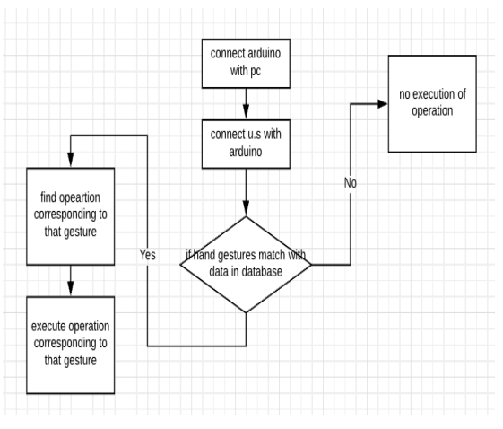

Flowchart of the Algorithm

5. SYSTEM MODEL:

* Circuit Diagram:

The circuit diagram of Arduino part of the model is shown below. It consists of an Arduino uno/nano board and two Ultrasonic Sensors. We can power up all these components from the laptop’s USB Port.

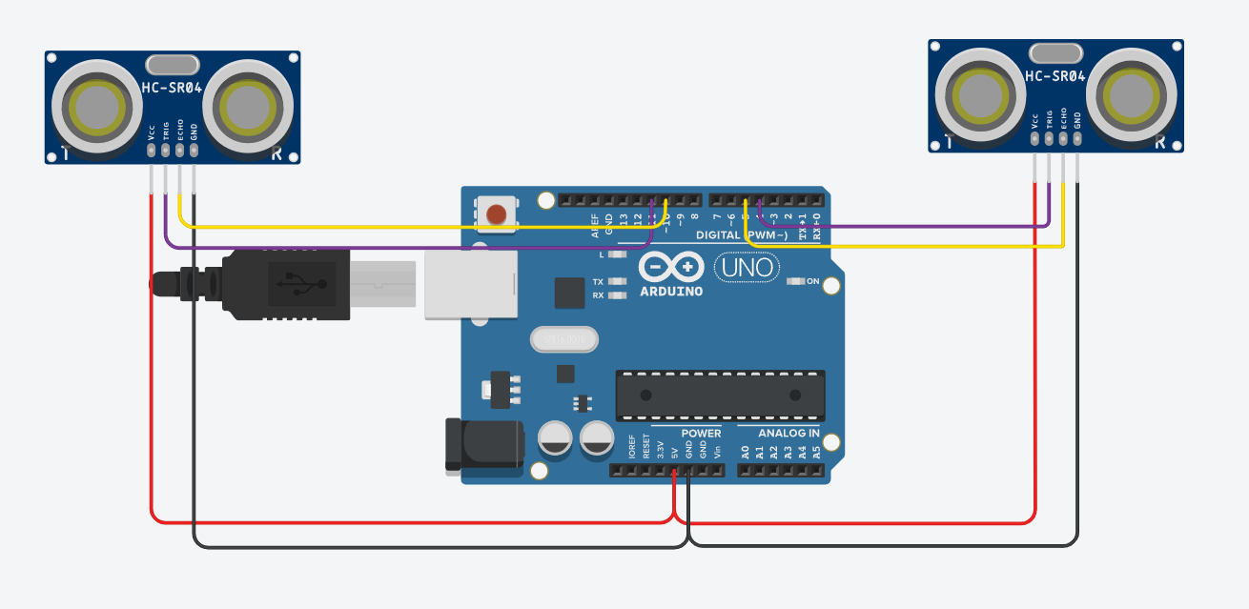

Circuit diagram of system